Adam Julius

November 30, 2018

Milstein-WP4

**Koreatown: A Developing Cultural Microcosm**

As I cruise the streets of downtown Los Angeles, Google Maps announces that I have arrived at my destination. Despite the fact that I am geographically in Koreatown, the lack of Korean spirit and influence remains perplexing. Rather than immersed in Korean culture as I envisioned, the streets are filled with Latino workers, neon strobe lights, and a Burger King juxtaposed by a posh, fifteen story high-rise. Myself, like many individuals, often turn trap to this misconception. Once a haven for all Korean immigrants, Koreatown transformed into a multi-cultural microcosm, best representative of the Los Angeles metropolis. The promotion of Angelino values of cultural heterogeneity, the consequential impact of the 1965 and 1980 Riots, and the advancement of urban construction, in conjunction with the influx of the “Millennial” generation, shape Korean Americans’ way of life and more importantly their identity. While many first-generation Koreans are attempting to preserve their customary way of life, the once spirited Korean culture quickly dwindles.

The image of Koreatown is rooted in its pride and traditions of diligence and hard work, the core foundation of all Koreans. Far from its humble beginnings, Koreatown now encapsulates an area that is five times larger than Little Tokyo and Chinatown combined. In search of a better life, Koreans not only fought through the many hardships of coming to the United States but also thrived. Koreans immigrated to America in three distinct waves: to escape Japanese oppression (prior to 1950), in reaction to the Korean War (1950-1964), and lastly due to the ratification of the 1965 Immigration and Naturalization Act (1965-1975). Koreans abandoned their status and successes in their homeland for dreams of a better life, and clung to principles of commitment and perseverance (lasting Koreatown values).

The first Korean community settled in America with “approximately 7,400 Koreans including students, merchants, and political exiles- 6,725 men, 675 women and children” (Myung 2007). Koreans, living life as the ethnic minority, worked to establish themselves in their new home. A modern lifestyle for Koreans started to develop, as Koreans advanced the creation of their newly born identity of cultural assimilation. After many years, Koreans acquired unwanted retail structures, vacant lots, and deserted streets—developing them into thriving businesses. Sparked by this prosperous expansion, many religious centers formed around this healthy economy: The Presbyterian Church, The L.A Christian Church, The Christian Church of Los Angeles, and the L.A. Korean Methodist Church. Koreans, once limited by what religion to practice, were no longer held to this restriction; this contributed to the evolution of Koreatown’s present day identity, its acceptance of all people, religions, ideas, and beliefs regardless of prior circumstances. However, this slow forming Korean identity was tested following the chaos of the Watts Riots, which caused severe damage to Korean merchants and small businesses.

Over the course of the violent 1965 Watts Riots, Koreatown’s residents experienced scorched liquor stores, looting, and the disruption of Koreatown’s economy. With the generation of havoc in people’s lives, the city’s demographics dramatically shifted following these extreme upheavals. The Watts tumult “that enveloped South L.A. [leaving] 34 people dead and 1,032 injured” (Loc 2016). The uproar startled the predominantly white middle class that was residing in present day Koreatown and resulted in many leaving the city. This 1965 scare precipitated rents to plummet, resulting in a flow of Koreans into the city, spurring a center of trade and commerce. The aftermath of the Watt Riots depicted unity and perseverance in the community, metamorphosing Koreatown into a place where any barrier could be hurdled. The economic depression following the Watts riots created resilience among new Koreans, allowing them to persevere in the future decades. Korean-Americans overcame one of the most difficult hardships that they will ever face, shaping a mindset of resolve and will power.

Koreatown’s development during the Olympic Boulevard and Wilshire Era set the precedent and principles that Koreans harnessed when expanding their cities’ boundaries. Proven a great contribution to the opening of new businesses, the massive growth in Koreatown in the late 19th century brought many changes. The successful development of the newly forming Koreatown economy was greeted with a rapid flow of various racial groups. Koreatown’s boundaries continued to expand, blending the virtues of Korean values with those of other ethnic groups, primarily Latino and African American. In 1980, Koreatown was finally granted a symbolic sign as the “City of Los Angeles officially designated the neighborhood just west of downtown Los Angeles as Koreatown” (Myung 2007). Undoubtedly a significant moment for the Korean community, the work ethic and determination of the Korean immigrants persisted through the adversity of adapting to a foreign landscape and the task of successfully creating a flourishing economy.

Koreatown’s disposition officially established with the inauguration of the Koreatown sign, recognizing Koreatown as a home of opportunity. The Korean community continued to advance just as a record high number of new Korean immigrants was reached, approximately 35,000 a year. This economic development, for better or worse, resulted with the former recognized boundaries being expanded and “many historic building such as the Brown Derby, the Gaylord Hotel, and the Chapman Market...transformed for other uses” (Myung 2007). Landmark Korean properties, including the aforementioned, continue to be rebuilt into Korean nightclubs, commercial hotels, and industrial office buildings. Koreatown exists as a borderless metropolis through physical and conceptual pathways: extending to new areas and heights, Koreatown’s quick expansion path foreshadows the influx of various people with juxtaposing ideas. Koreans came to Downtown Los Angeles with few resources yet were able to build a prosperous life for themselves. This spurred the Korean-American identity as outsiders believed they too could come to Koreatown with the hope of making a name for themselves. The ambition for any immigrant, and the philosophy of Koreatown today, is to make a better life than the one left behind. Concurrent with the events of these great expansions and the foundation of a Korean-American identity, Koreatown’s swift growth was propelled to a halt once more, with the turmoil of violence of the Los Angeles Riots.

Many years elapsed and the resulting mindset that was formed from the Watt riots, the Olympic Boulevard era discussed earlier, as well as the inauguration of the Koreatown sign, transformed the area into a prosperous hub of commerce. For a brief decade, tensions eased as the identity of Koreatown experienced a cultural diversification. This prosperity came to a tremendous standstill on April 30, 1992 when the city of Angels raged in flames and smoke during the Rodney King Riots. Often proclaimed the most significant contemporary event for Korean Americans, the riots had a lasting impression on Korean American’s way of life: “What was an immigrant Korean identity began to shift and the Korean-American identity was born” (Lah 2017). The extensive violence produced a billion dollars’ worth of damage, half of which was sustained by Korean-owned businesses. Creating juxtaposition in spite of all the anger, the wealthy Koreans willingly abandoned their once called home while the poor Korean community bravely united. Chang Lee, a survivor of the LA riots, portrayed promise in his hometown community through the recitation of the events that followed the anarchy, recalling, “One by one neighbors come out to help. They were black, Korean, Latino. 30 people. They gave me hope. They are my community. And it’s time again to stay bound together” (Lah 2017). Many Koreans who left resented those who destroyed their livelihood, but those who decided to remain created a culture of acceptance and possibility. United, the community chose to look for the best in people, gradually manifesting into the unique cultural microcosm that exists today. Koreatown started to embrace the contemporary shift of Los Angeles, and the ensuing variance of urban construction and changing demographics, highlights the rapidly changing cultural hub of the neighborhood.

Beginning in 2010, the rapid advancement in construction and the influx of the “Millennial generation” is notable in reshaping the old identity of Koreatown and redefines the characteristics of its present day form. The so-called “Millennial” generation emerges in the forefront, producing a new wave of people, office structures, and traditions. Regardless, the growth of Koreatown is accompanied with a surge in jobs, diversity, and new ideas. Jamie Lee, the CEO of a large retail firm, explains, “Koreatown is the epitome of a transit-oriented, cultural epicenter” (Jordan 2017). At the heart of Los Angeles, Koreatown always evolves, representative of core Angelino values. The city quickly becomes unrecognizable, with mainstream buildings going up left and right throughout the area. Through years of reconstruction and modernization, the loss of traditional Korean architecture accompanies the erosion of old Korean heritage. Below, the illustrative map of urban construction projects is significant. Koreatown’s new developments as pictured, are scattered around the city, singlehandedly reinventing the neighborhood:

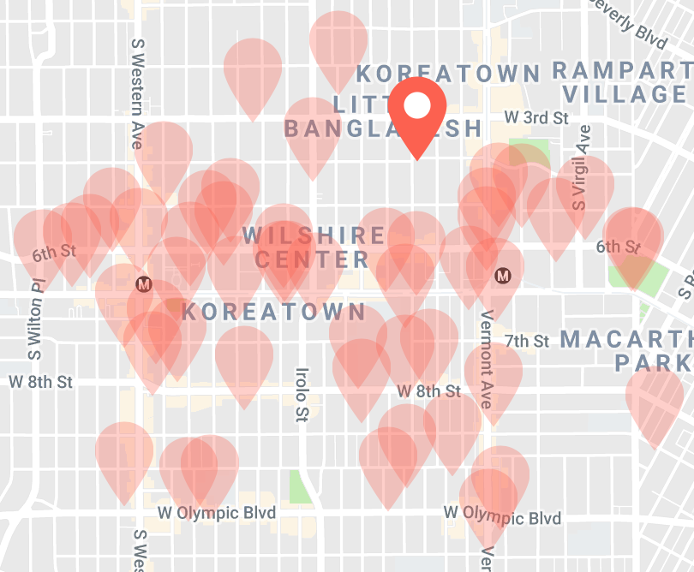

What is clear is that the Korean values of the city no longer take precedence and are overshadowed by the dominance of the changing urban landscape. Indicators of the landscape becoming more developed and urbanized, the red pins display the inevitable loss of Korean buildings and remaining heritage; this departure of more traditional Korean structures is replaced by luxury eateries, high-rise hotels, and modernized retail shops. The ethics and principles of Korean traditions are diffused by the assimilation of modern American construction and the disappearance of Korean-owned offices, stores, restaurants, and parlors. Koreatown’s heterogeneous elements of infusion symbolize an Angelino metropolis mecca as the endless renovations of Koreatown’s landscape and varied demographics allow the city to be ever evolving.

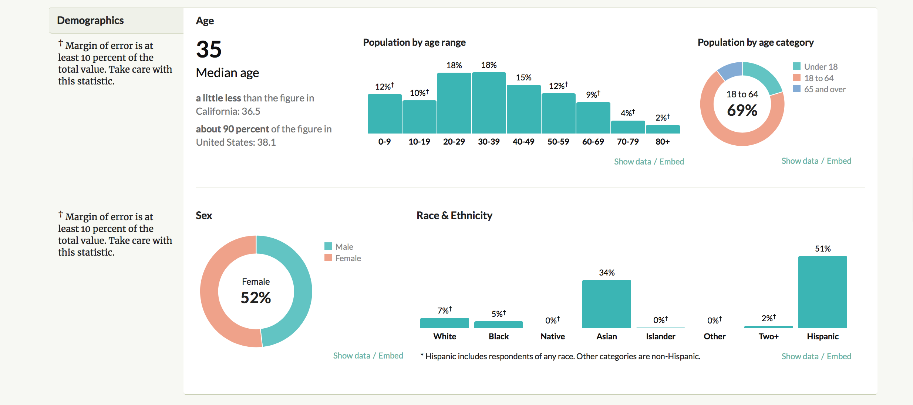Koreatown is fascinating, mysterious and through its inability to be defined, is representative of a transnational borderline between the United States and Korea. In discussing Koreatown’s notion of culture, the city’s identity from its perspective of transnational formation becomes evaluated. Located in the United States, Koreatown can’t be identified as an extension of Korean sovereignty, yet a farther reach is claiming the town as representative of the United States. Koreatown, a multiracial community, is divergent though “the majority of businesses are Korean, the majority of the population is Hispanic, and the politics is mainly controlled by whites and blacks” (Koh 2007). Contrasting race and ethnicity, Koreatown departs from the norm, generating a melting pot of cultural values and ideals. The neighborhood, through its transnational elements, encourages individuals to migrate to the area for a fresh start. By examination of Koreatown’s demographics, a disparity is highlighted juxtaposing the label of “Koreatown” and its deviated population distribution:



Markedly, this city is a Korean establishment yet the majority of the population is Hispanic. Roughly half of the population is currently under the age of 39, many of whom are not Korean. Statistically, this illustrates the likelihood that most first generation Koreans deserted their once called home after making a profitable living. When Koreans originally come to Koreatown, they wanted to be surrounded by familiar faces, food, and culture. However, this desire or craving to be in a comfortable surrounding shortly dwindles as they accumulate wealth, no longer wanting to live in Koreatown. Koreatown is an ethnic enclave that wouldn’t exist in the United States “without heterogeneous elements within it” (Koh 2007). By the inability of Koreatown’s to be defined, people ironically turn up in Koreatown as a place to be defined fix. Koreatown, most unique in its fragmented attributes, offers individuals a haven for a chance at a better life. Additionally, Koreatown’s signs and food scene paint a contrasting picture of the elements shaping the neighborhood.

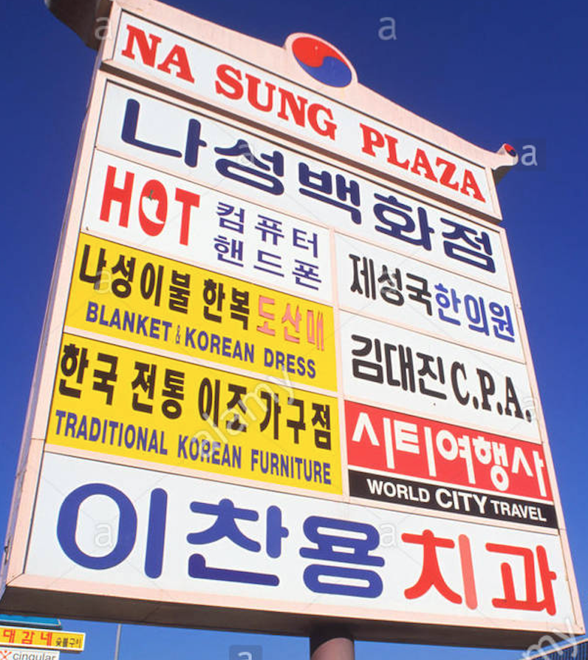Through the evolving signs, cultural billboards, and food scenes taking place, Koreatown currently wishes to attract people of various ethnic backgrounds; this development materializes as a stark contrast to the Korean centric lifestyle of the past. In previous years, the area purposely challenged non-Korean communities in an incendiary manner, and symbolized a desire to only attract Korean customers. Surprisingly, most of Korean business and affairs aimed at attracting an ethnic Korean public, at the expense of profit for their family-owned businesses. Commonly, business signs are intended to draw in potential customers and those who cannot read the billboard, in many instances, are purposely excluded. Depicted, the image displays a prominent example of a Korean business sign along Vermont Avenue that exemplifies the notion of the enclave character of Koreatown during that time period. Na Sung Plaza, operating as a busy center of trade, embodies a typical retail square. Through translation of the Korean scripture, I learned that Na Sung Plaza consists of a Department Store, Computer Mobile Phone Shop, Traditional Korean Furniture warehouse, a Travel Agency, and a “Chanomom” Dentistry department. The entities that constitute the Na Sung Plaza are conventional stores containing frequent necessities for daily life thereby effectively asserting the plaza as the town’s retail hub. The Na Sung Plaza, like many older Korean establishments, was exclusive to only literate Korean individuals. Years ago, Korean Americans were portrayed as maintaining their own ethnically-defined Koreatown by, “those who cannot read Korean will… be excluded” (Koh 2007). Once neglecting to offer adequate information to non-Korean folks, Koreans were not willing to share their customs and lifestyles with other people. Nowadays, this is no longer the case. Koreatown’s truly iconic Korean foods have become trendy and the food scene progresses, catering to many different types of people. The reshaping identity of the food scene becomes one of many influential factors that shift Koreatown away from a strict Korean community to a multi-ethnic city. Koreatown, once a culture strictly for Koreans, has dynamically altered paths with the acceptance of non-Koreans eating staple Korean foods such as kimchi and bulgogi. David Chang, a world-renowned Korean chef expresses that, “Food is something that we all have in common. It’s an essential part of who we are and how we create connections across cultures” (Kennedy 2018). As a bridge between Koreatown and its new residents, food acts as a widespread platform that allows outsiders to embrace Korean food and other facets of its culture while contributing their own non-Korean customs. The link between the earlier divide of the old and new residents of the city, represents the promotion of cultural heterogeneity. This notion is highlighted by the interview with a Koreatown resident and unexpectedly the lack of murals in Koreatown’s key transit locations. Through my conversation with Justin, an eight-year resident, and the journey through seeing Koreatown murals, I learned that the town has little Korean heritage remaining. Despite its name, Koreatown barely resembles Korean traditions, beliefs, or attitudes. Coming to the United States in escape of oppression, Koreatown was a temporary place for impoverished Koreans to start their new lives. Many Koreans wanted to move to Koreatown initially, afraid to assimilate with American culture, but soon choose to leave and look for opportunities elsewhere (Justin 2018). Now, the wealthy Korean-Americans find areas such as Glendale and San Fernando Valley more desirable. Koreatown is left as a place of hard-working poor Koreans, Latinos, and Millennials aspiring to one day live outside of Koreatown too. The Latinos and the Millennial generation dream of becoming wealthier, as history shown previous Korean-Americans creating profitable businesses in the exact locale. In addition, the murals throughout Koreatown are fading away and the ones that do exist portray little to no Korean values. Rather, the murals located at Wilshire Western train station, at the 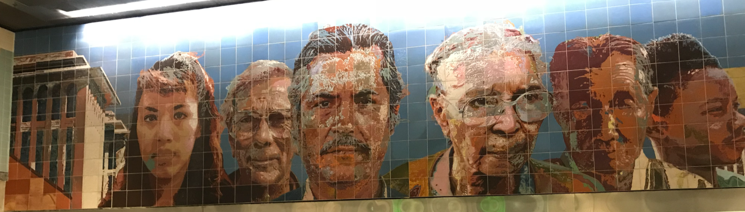heart of Koreatown, represent the Latino population:

Figure 1: Na Sung Plaza (Korean Retail Center)

Na Sung Plaza: Korean Retail Center

The mural exhibits strength, determination, and tireless effort in the faces depicted, representative of fundamental Korean values that still encapsulates the identity of Koreatown. While Koreatown’s identity is hardly discerned as Korean, the area will always remain as a haven for people, including immigrants, as a starting off or rebounding point in life. Even with this loss of the old Korean identity, Koreatown signs and street symbols still remain, as the Korean community doesn’t want to completely alienate the old Korean ways and portray the abandonment of the only place that gave them an opportunity.

Koreatown, representative of the Los Angeles Metropolis, experiences ethnic diversity depicted by the departure of the affluent Korean Americans and the influx of the “Millennial” generation. The advancement of urban landscape and the loss of Korean murals, ultimately, leads to the diffusion of Korean culture. The unique path of Koreans establishing themselves in the United States, advances the creation of the identity of Koreatown from strict Korean values to a melting pot of beliefs. Koreatown, once a one-dimensional affair, now exhibits the epitome of the promotion of cultural heterogeneity. A neighborhood is defined by the thoughts of the people, the awareness of food, and the symbolism personified by the traits of the inhabitants. Thus, prospective Korean residents, aspired to improve their socio-economic status, exploit Koreatown’s alluring business opportunities as a wish to eventually depart and live a better life elsewhere. Shaped by the heterogeneous populous and adapting infrastructure, the customary microcosm resembles that of an Angelino metropolis mecca. At the center of this mecca, exists the evolving food scene, illustrating its own story, attracting all people of all cultures.